For Immediate Release: Clark County Arts Commission and Vancouver City Hall pleased to present artwork of Shannon Buck, Ann Cavanaugh, Tom Relth, and Dannika Sullivan

Vancouver City Hall Announces New Artwork

Clark County Arts Commission and Vancouver City Hall are proud to present the artwork of four regional artists: Shannon Buck, Ann Cavanaugh, Tom Relth, and Dannika Sullivan. The artwork of these local creatives range in medium through traditional painting and printmaking techniques, as well as drawing and glass working.

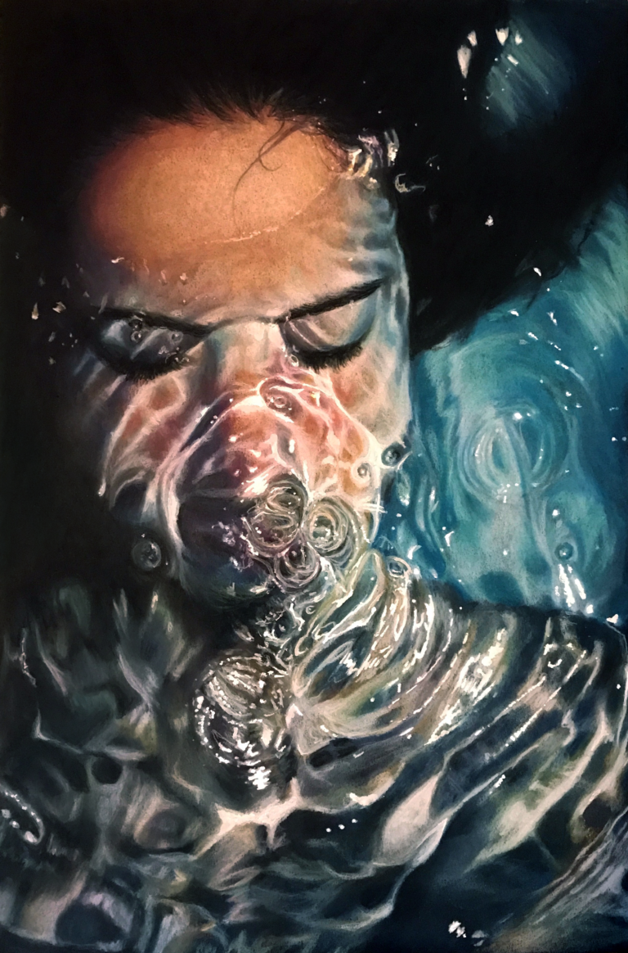
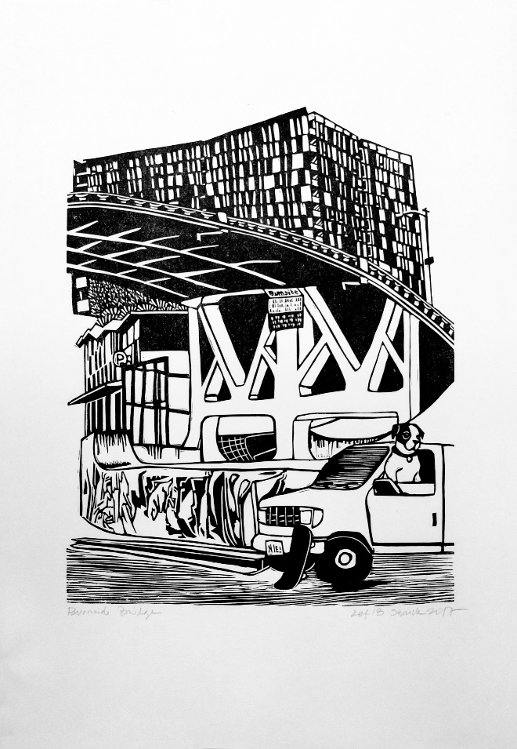
Shannon Buck is a printmaker and painter known for her quirky characters and socially conscious illustrations. Buck’s community centric approach to printmaking and artistic expression are evident in her place specific artwork created using letterpress and linotype printmaking. She views printmaking as a balancing act between light and dark. To view more of Shannon’s work please visit https://www.etsy.com/people/loadedhipspress
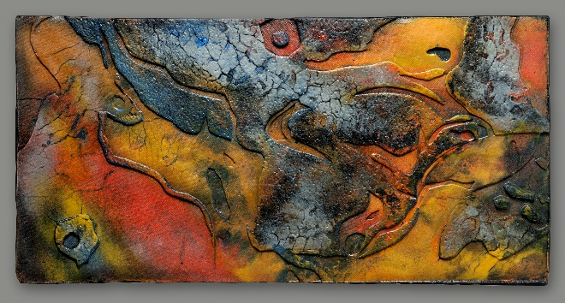

Ann Cavanaugh is a glass artist whose passion for the outdoors is evident in many of her colorful creations. Cavanaugh’s love of learning inspires her to continue stretching her practice, while her commitment to community contributes to her enthusiasm for teaching. For more information about Ann’s work please visit http://www.anncavanaugh.com/

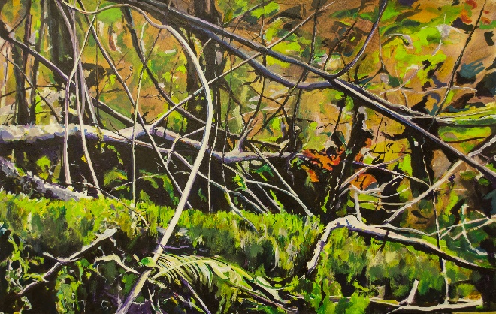

Tom Relth is a painter and multidsciplinary artist whose colorful works focus on the tangled and complicated natural world. Escewing traditional landscape in favor of the closeup and chaotic, his paintings challenge the viewer to connect with their own survival instincts though imagined landscapes. For more information about Relth’s work, please visit http://www.relth.org/

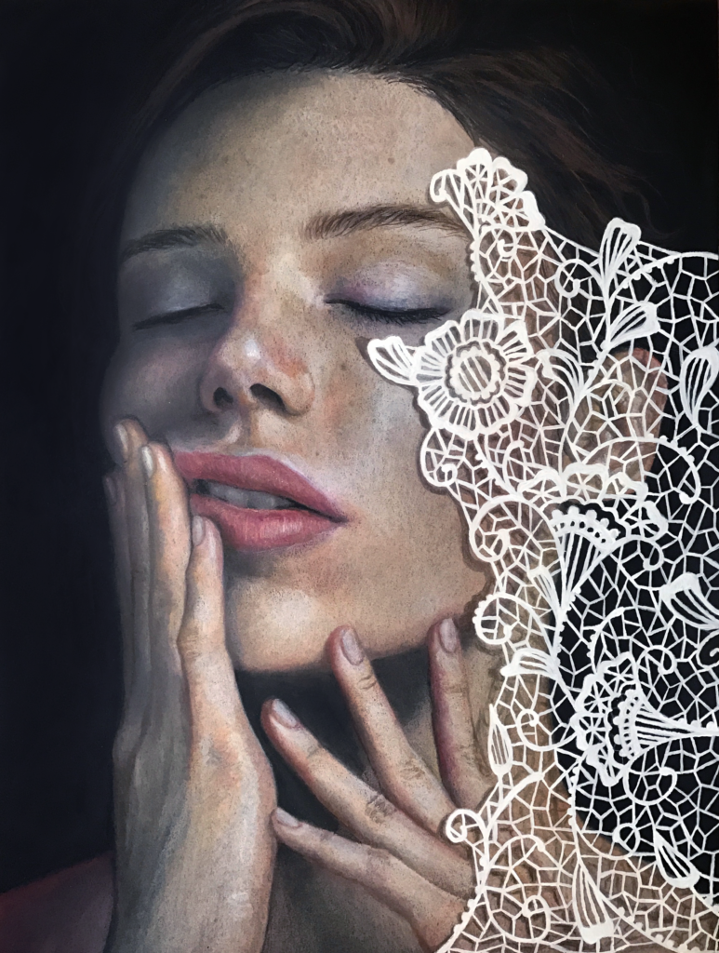
Dannika Sullivan is a self taught artist whose work is created using chalk pastel on black paper. Her fluidly realistic portraits often depict her subjects in water based scenes. Her commitment to continued learning and technique are evident in her continually growing portfolio. For more information about Sullivan’s portraits, please visit http://www.dannikarose.com/

Work from Shannon Buck, Ann Cavanaugh, Tom Relth, and Dannika Sullivan will be on display at Vancouver City Hall from March 9th through May 31st.

City Hall is located at 415 W. 6th Street, Vancouver, WA 98660. The lobby is open 8-5 Monday - Friday. Artwork in the conference rooms is available by appointment for viewing when the space is not being used for city business and meetings. For more information about artwork at Vancouver City Hall please contact Jess Graff at jlgraff17@gmail.com

